Experiencing problems with OE account unlock – the following Is not working:

If you do not unlock the OE, and HR users during Oracle Database 11g installation, perform the following:

**a**. Open a terminal window, and type the following command:

sqlplus sys/oracle as sysdba;

**b**. Once you get connected as sys, then, unlock the OE, and HR accounts.Then, grant dba role to OE, and HR. Grant SELECT_CATALOG_ROLE to OE. In the SQL*Plus window, type the following commands. Alternatively, run the script accounts.sql:

ALTER USER HR IDENTIFIED BY HR ACCOUNT UNLOCK;  
ALTER USER OE IDENTIFIED BY OE ACCOUNT UNLOCK ;  
GRANT DBA to OE, HR;  
GRANT SELECT_CATALOG_ROLE TO OE;

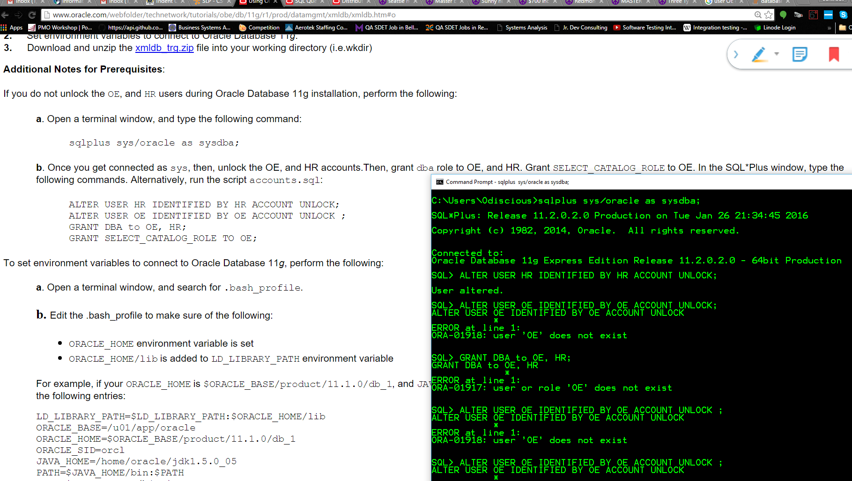

After several hours of search (times spent on phone and emailing professors), I have found a way to execute a SQL file from the command line.

Hey professors,

I found out what we were doing wrong.  In the SYSTEM or SYS user, we needed to execute the oe_main.sql file.  This can be done from the command line and I'm not sure of how else to do it.

There are steps given to do this in the SLP 01 assignment.

Next, the oe_cre.sql needs to be ran.  I ended up stripping all of the comments out, logged in as user OE, and ran the script as a bunch of sql statements in a file.

Step one created the user and step two created all the tables and their relationships.  Here's what the instructions look like - a bit misleading.

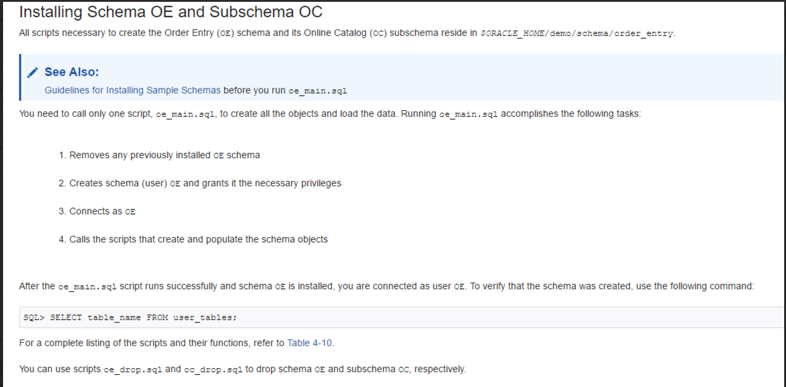

Here's what Oracle SQL Developer now looks like:

